ADITHYA
192311369
8 Create a Virtual Hard Disk and allocate the storage using virtual box.
AIM:
To create a virtual hard disk in VirtualBox and allocate storage for a virtual machine.

PROCEDURE:
*Open VirtualBox and select the virtual machine (or create a new one).
*Click Settings → Storage → Controller → Add Hard Disk → Create New Disk.
*Choose the disk type (VDI – VirtualBox Disk Image) and click Next.
*Select Storage on Physical Hard Disk → Dynamically Allocated or Fixed Size, then click Next.
*Set the disk size (e.g., 15 GB) and choose the location to save the disk.
*Click Create to finish the virtual hard disk allocation.

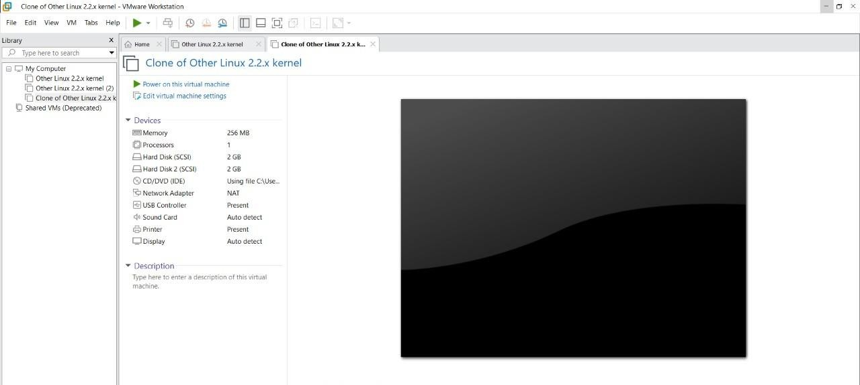

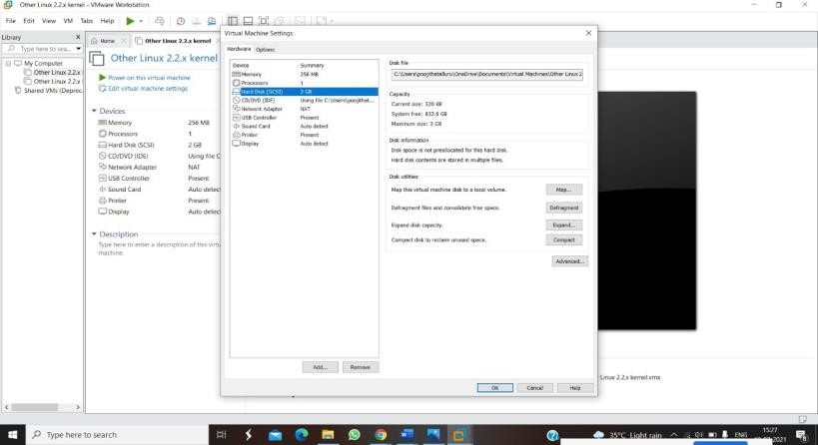
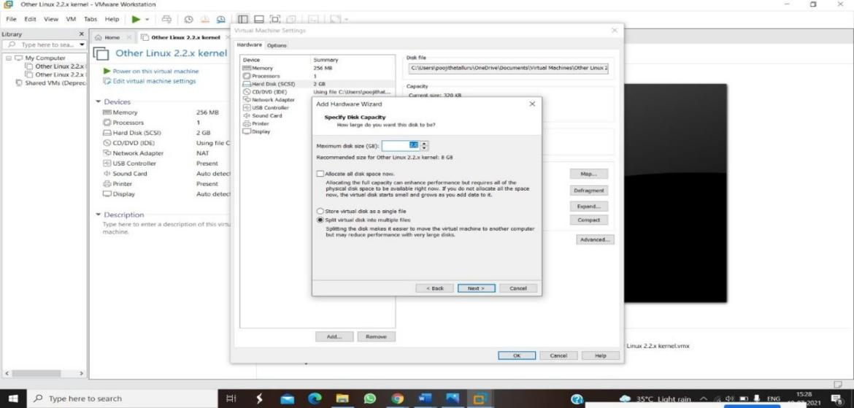

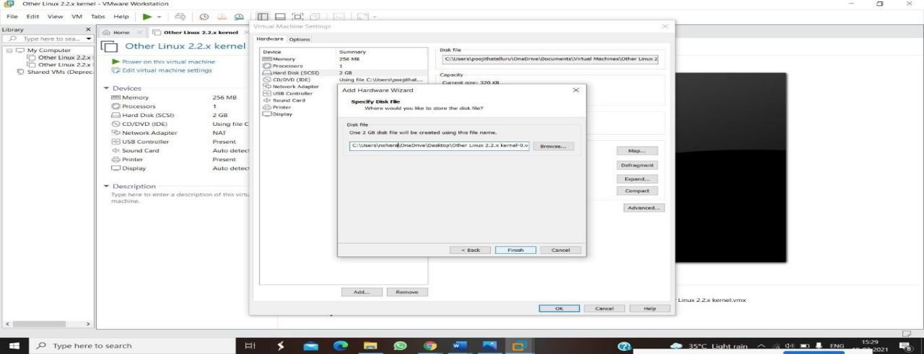

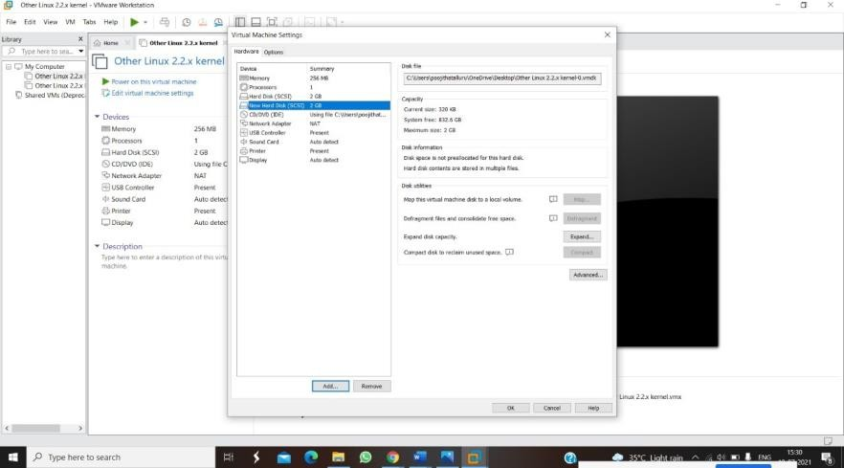

RESULT:
A virtual hard disk of the specified size is successfully created and attached to the virtual machine. The VM can now use this storage for installing an operating system and storing data.

